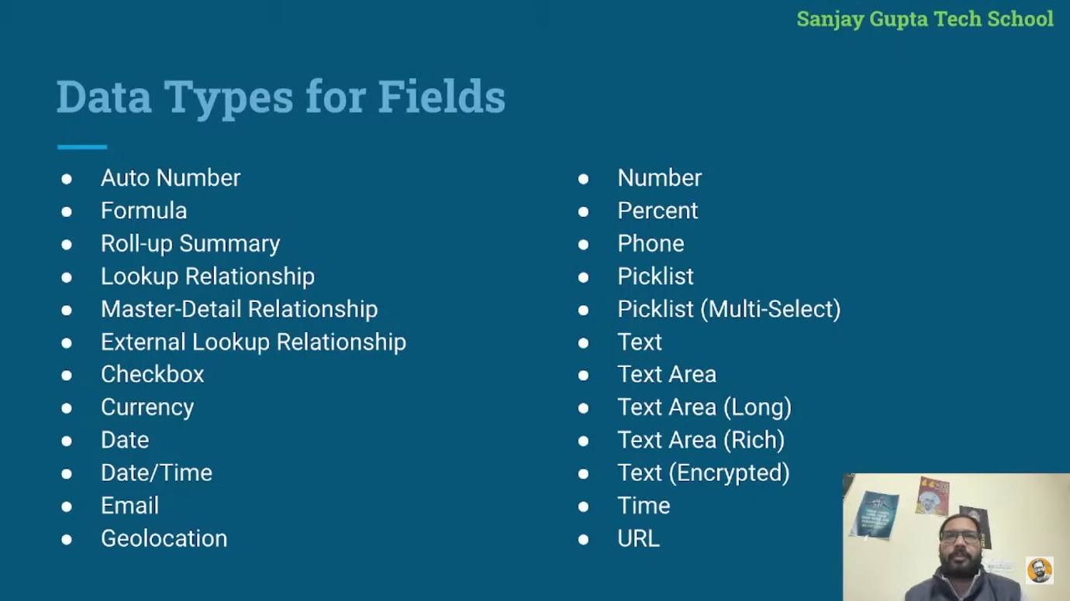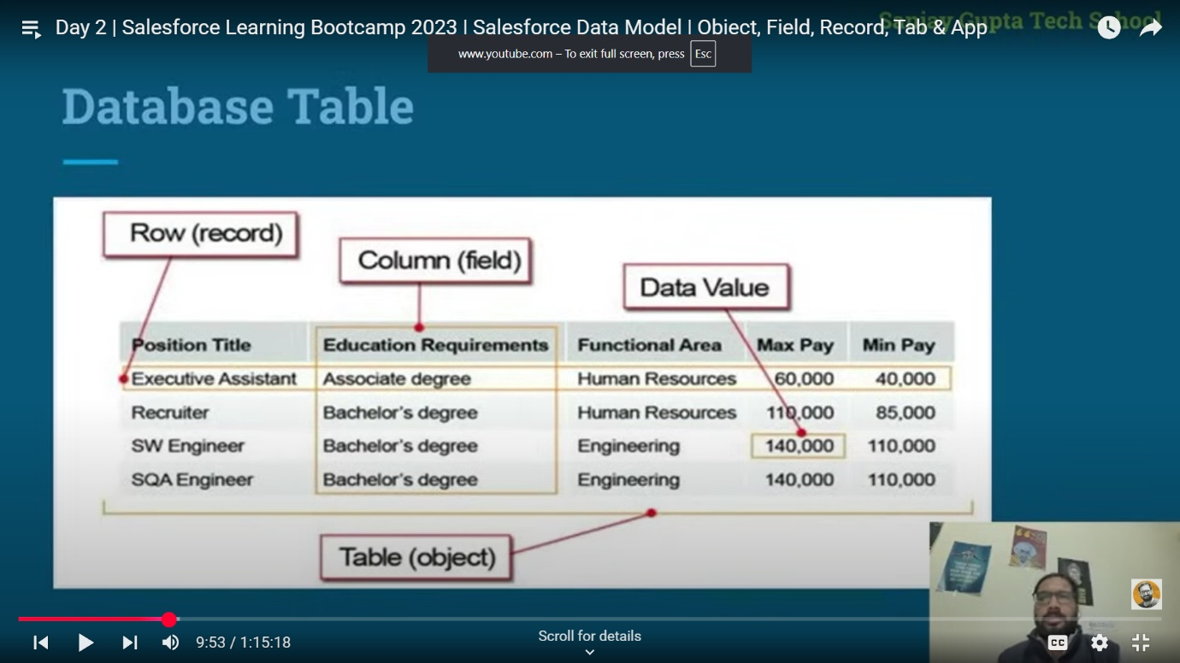
Here is your corrected and aligned version of the notes for Apex and Salesforce basics. I’ve kept all content intact and only fixed spelling, grammar, punctuation, and formatting to make it easier to study:

OBJECT, TAB, FIELD, RECORD, APP
- Object is similar to a database table – e.g., Account, Sales, Lead, Contact.
- Standard Objects like Salesforce Sales and Salesforce Service.
- Custom Object in Salesforce is created as per the requirement of the project.
Object Fields
- Label – the name of the object.
- Plural Label – the name with "s" added.
- API Name – in standard objects, the name is displayed as it is; in custom objects, __c will be added.
  - Plural name is used for Tabs.
  - API Name is used in Flow, Apex, etc.

Fields
- Like database columns; various data types are used to create fields.
- Entering values in fields results in new record creation.

Records
- Records are rows in an object.
- Each record has a unique ID.
- You can Create, Edit, View, and Delete records in Salesforce.

App
- App is a container for all Objects and Tabs.
- App consists of Name, Logo, and an ordered set of Tabs.

Day 2: Apex Basics
Integer x = 5, y = 6, z;
z = x + y;
System.debug('Sum = ' + z);
Class Example
Rectangle rec = new Rectangle(); // instance creation
rec.area(); // calling method
Custom Class with Constructor
RectangleWithConstructor rec = new RectangleWithConstructor(); // instance creation
rec.area();
rec.perimeter();
Parameterized Constructor
RectangleWithConstructor rec = new RectangleWithConstructor(4, 5);
rec.area();
rec.perimeter();

Class Definitions
Without Constructor
public class Rectangle {
public void area() {
Decimal length = 5.5, breadth = 6;
Decimal a = length * breadth;
System.debug('Area = ' + a);
}
}
With Default Constructor
public class RectangleWithConstructor {
Decimal length, breadth;

public RectangleWithConstructor() {
length = 5.5;
breadth = 6;
}

public void area() {
Decimal a = length * breadth;
System.debug('Area = ' + a);
}

public void perimeter() {
Decimal p = 2 * (length + breadth);
System.debug('Perimeter = ' + p);
}
}
With Parameterized Constructor
public class RectangleWithConstructor {
Decimal length, breadth;

public RectangleWithConstructor(Decimal l, Decimal b) {
length = l;
breadth = b;
}

public void area() {
Decimal a = length * breadth;
System.debug('Area = ' + a);
}

public void perimeter() {
Decimal p = 2 * (length + breadth);
System.debug('Perimeter = ' + p);
}
}

Day 3: Static Method Demo
DemoApex.method1();
DemoApex.method2();
DemoApex.method3();

Calculator.addition();
Calculator.subtraction();
Calculator.multiplication(10, 2);
DemoApex Class
public class DemoApex {
public static void method1() {
Boolean isActive = false;
System.debug('Value of isActive: ' + isActive);
}

public static void method2() {
String fname = 'Sanjay', lname = 'Sindhuja';
System.debug('Name = ' + fname + ' ' + lname);
}

public static void method3() {
ID accId = '005dL00000HKt8hQAD';
System.debug('Id = ' + accId);
}
}
Calculator Class
public class Calculator {
public static void addition() {
Integer var1 = 5, var2 = 10, sum;
sum = var1 + var2;
System.debug('Addition = ' + sum);
}

public static void subtraction() {
Integer var1 = 5, var2 = 10, sub;
sub = var1 - var2;
System.debug('Subtraction = ' + sub);
}

public static void multiplication(Integer var1, Integer var2) {
Integer mul = var1 * var2;
System.debug('Multiplication = ' + mul);
}
}

sObject as Data Type
Anonymous Window
Account acc = new Account();
acc.Name = 'SGTS';
acc.Rating = 'Hot';
acc.Active__c = 'Yes'; // Only if 'Yes' is a valid picklist value

insert acc;
Apex Class
public class AccountRecord {
public static void insertData() {
Account acc = new Account();
acc.Name = 'SGTS 2';
acc.Rating = 'Warm';
acc.Active__c = 'Yes';
insert acc;
}
}
// Run using: AccountRecord.insertData();

Day 4: Account-Contact Relationship
public class AccountRecord {
public static ID insertAccount(String name, String rating, String active) {
Account acc = new Account();
acc.Name = name;
acc.Rating = rating;
acc.Active__c = active;
insert acc;
return acc.Id;
}

public static void insertContact() {
Id accId = insertAccount('CGST', 'Weather', 'Yes');
Contact con = new Contact(FirstName = 'Contact 101', LastName = 'Con201');
con.AccountId = accId;
insert con;
}
}
// AccountRecord.insertContact();

Account with Related Contact and Opportunity
public class AccountRecord {
public static void insertAccountWithConAndOpp(String name, String rating, String active) {
Account acc = new Account();
acc.Name = name;
acc.Rating = rating;
acc.Active__c = active;
insert acc;

Contact con = new Contact(FirstName = 'Contact101', LastName = 'Con 201');
con.AccountId = acc.Id;
insert con;

Opportunity opp = new Opportunity();
opp.Name = 'Opp 101';
opp.CloseDate = System.today();
opp.StageName = 'Prospecting';
opp.AccountId = acc.Id;
insert opp;
}
}
// AccountRecord.insertAccountWithConAndOpp('RAGU', 'Fit', 'Yes');

Day 5: Conditional Statements
public class ConditionalStmtDemo {

public static void logicalOperatorsDemo() {
Integer num1 = 10, num2 = 30;

if (num1 > 5 || num2 > 100) {
System.debug('true');
} else {
System.debug('false');
}
}

public static void elseifLadderDemo(Integer num) {
if (num > 0) {
System.debug('Number is positive');
} else if (num == 0) {
System.debug('Number is zero');
} else {
System.debug('Number is Negative');
}
}

public static void nestedIfDemo(Integer num) {
if (num >= 0) {
if (num > 0) {
System.debug('Number is positive');
} else {
System.debug('Number is Zero');
}
} else {
System.debug('Number is negative');
}
}

public static void checkEvenOdd(Integer num) {
if (Math.mod(num, 2) == 0) {
System.debug('Number is Even');
} else {
System.debug('Number is Odd');
}
}

public static void max(Integer num1, Integer num2) {
if (num1 > num2) {
System.debug('Num1 is max as compared to Num2');
} else {
System.debug('Num2 is max as compared to Num1');
}
}

public static void checkEligibility(Integer age) {
if (age >= 18) {
System.debug('You are eligible to vote');
} else {
System.debug('You are not eligible to vote');
}
}
}

Day 6: Loops
For Loop
public class LoopDemo {

public static void sumOfNaturalNums(Integer n) {
Integer sum = 0;
for (Integer i = 1; i <= n; i++) {
sum += i;
}
System.debug('Sum = ' + sum);
}

public static void forDemo() {
for (Integer i = 1; i <= 10; i++) {
System.debug(i);
}
}

public static void evenNum(Integer n) {
for (Integer i = 1; i <= n; i++) {
if (Math.mod(i, 2) == 0) {
System.debug(i);
}
}
}

public static void table(Integer n) {
for (Integer i = 1; i <= 10; i++) {
System.debug(n + ' * ' + i + ' = ' + (n * i));
}
}
}
While Loop
public class LoopDemo {
public static void tableWithWhile(Integer n) {
Integer i = 1;
while (i < 10) {
System.debug(n + ' * ' + i + ' = ' + (n * i));
i++;
}
}
}

Loop with List, Set, and Map
public class LoopDemo {

public static void showList() {
List<Account> accList = new List<Account>();
Set<Id> accIds = new Set<Id>();
Map<Id, Account> accMap = new Map<Id, Account>();

accList = [SELECT Id, Name FROM Account LIMIT 5];

if (accList.size() > 0) {
for (Account acc : accList) {
System.debug(acc.Id + ' - ' + acc.Name);
accIds.add(acc.Id);
accMap.put(acc.Id, acc);
}
}

System.debug('Display data through set');
for (Id accId : accIds) {
System.debug(accId);
}

System.debug('Map based on keys');
for (Id accId : accMap.keySet()) {
System.debug(accId);
}

System.debug('Map based on values');
for (Account acc : accMap.values()) {
System.debug(acc);
}
}
}

Trigger in Salesforce
- Trigger is used to perform operations that cannot be done with point-and-click tools in Salesforce.
- Triggers can be created for both Standard and Custom Objects.
Types of Triggers
- Before Trigger – used to update or validate values before saving to DB.
- After Trigger – used to access values that are set by the system, and after the record is inserted.

